Flag Register of 80386 micro processor

Flag Register of 80386
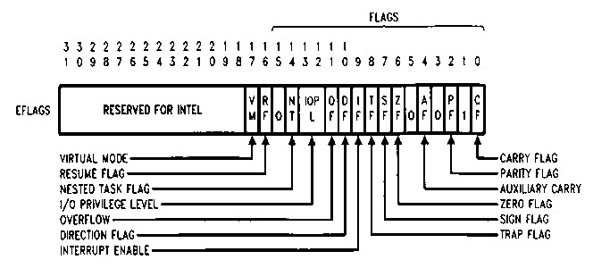
[ source: Intel386 DX Manual]

Note in these descriptions, ``set'' means ``set to 1,'' and ``reset'' means ``reset to 0.''

VM (Virtual 8086 Mode, bit 17)
The VM bit provides Virtual 8086 Mode within Protected Mode. If set while the 80386 is in Protected Mode, the 80386 will switch to Virtual 8086 operation, handling segment loads as the 8086 does, but generating exception 13 faults on privileged opcodes.
RF (Resume Flag, bit 16)
The RF flag is used in conjunction with the debug register breakpoints. It is checked at instruction boundaries before breakpoint processing. When RF is set, it causes any debug fault to be ignored on the next instruction. RF is then automatically reset at the successful completion of every instruction.

NT (Nested Task, bit 14)
This flag applies to Protected Mode. NT is set to indicate that the execution of this task is nested within another task. If set, it indicates that the current nested task's Task State Segment (TSS) has a valid back link to the previous task's TSS. This bit is set or reset by control transfers to other tasks.

IOPL (Input/Output Privilege Level, bits 12-13)
This two-bit field applies to Protected Mode. IOPL indicates the numerically maximum CPL (current privilege level) value permitted to execute I/O instructions without generating an exception 13 fault or consulting the I/O Permission Bitmap. It also indicates the maximum CPL value allowing alteration of the IF (INTR Enable Flag) bit when new values are popped into the EFLAG register.
OF (Overflow Flag, bit 11)
OF is set if the operation resulted in a signed overflow. Signed overflow occurs when the operation resulted in carry/borrow into the sign bit (high-order bit) of the result but did not result in a carry/borrow out of the high order bit, or vice-versa. For 8/16/32 bit operations, OF is set according to overflow at bit 7/15/31, respectively.
DF (Direction Flag, bit 10)
DF defines whether ESI and/or EDI registers post decrement or post increment during the string instructions. Post increment occurs if DF is reset. Post decrement occurs if DF is set.
IF (INTR Enable Flag, bit 9)
The IF flag, when set, allows recognition of external interrupts signaled on the INTR pin.
When IF is reset, external interrupts signaled on the INTR are not recognized. IOPL indicates the maximum CPL value allowing alteration of the IF bit when new values are popped into EFLAGS or FLAGS.
TF (Trap Enable Flag, bit 8)
TF controls the generation of exception 1trap when single-stepping through code. When TF is set, the 80386 generates an exception 1 trap after the next instruction is executed. When TF is reset, exception 1 traps occur only as a function of the breakpoint addresses loaded into debug registers DR0±DR3.
SF (Sign Flag, bit 7)
SF is set if the high-order bit of the result is set, it is reset otherwise. For 8-, 16-, 32-bit operations, SF reflects the state of bit 7, 15, 31 respectively.
ZF (Zero Flag, bit 6)
ZF is set if all bits of the result are 0. Otherwise it is reset.
AF (Auxiliary Carry Flag, bit 4)
The Auxiliary Flag is used to simplify the addition and subtraction of packed BCD quantities. AF is set if the operation resulted in a carry out of bit 3 (addition) or a borrow into bit 3 (subtraction). Otherwise AF is reset. AF is affected by carry out of, or borrow into bit 3 only, regardless of overall operand length: 8, 16 or 32 bits.
PF (Parity Flags, bit 2)
PF is set if the low-order eight bits of the operation contains an even number of ``1's'' (even parity). PF is reset if the low-order eight bits have odd parity. PF is a function of only the low-order eight bits, regardless of operand size.
CF (Carry Flag, bit 0)
CF is set if the operation resulted in a carry out of (addition), or a borrow into (subtraction) the high-order bit. Otherwise CF is reset. For 8-, 16- or 32-bit operations, CF is set according to carry/borrow at bit 7, 15 or 31, respectively.

